Cricket Player Performance Tracking Application : CRICKSTATS

Team ID : SWTID-2026-7718
Team Size : 5
Team Leader : VIMAL VASAN M.R
Team member : GOKULRAJ S
Team member : GUBENDHIRAN A
Team member : HARIPRAKASH B
Team member : ILAVARASAN A

ABSTRACT

- Cricket is a sport deeply rooted in statistics, where every run, wicket, and catch contributes to the narrative of performance. Traditional scorecards often fail to provide deeper insights into player efficiency and long-term trends. CRICKSTATS is a performance tracking application designed to bridge this gap by offering a comprehensive platform for recording, analyzing, and visualizing cricket data. The system empowers coaches, analysts, players, and fans with real-time statistics, interactive dashboards, and predictive insights. By integrating modern technologies such as cloud computing, APIs, and data visualization, CRICKSTATS transforms raw match data into actionable knowledge, enhancing decision-making and engagement at all levels of the game.
The evolution of modern cricket has created a demand for advanced performance tracking systems that go beyond traditional scorekeeping. CRICKSTATS is designed as a comprehensive solution to capture, store, and analyze player data across batting, bowling, and fielding dimensions. By leveraging cloud-based infrastructure, real-time APIs, and interactive visualization tools, the application transforms raw match statistics into meaningful insights. Coaches and selectors gain a powerful decision-support system, players receive personalized feedback to enhance their skills, and fans enjoy deeper engagement with the sport. CRICKSTATS not only serves as a statistical repository but also as a predictive and analytical platform, paving the way for data-driven strategies in cricket management and performance optimization

S.NO | CONTENTS
1 | INTRODUCTION
2 | IDEATION PHASE
3 | REQUIREMENT ANALYSIS PHASE
4 | PROJECT DESIGN PHASE
5 | PROJECT PLANNING AND SCHEDULING
6 | PROJECT DEVELOPMENT PHASE
7 | FUNCTIONAL  AND PERFOMANCE TESTING
8 | CONCLUSION

1. INTRODUCTION
  - Cricket is one of the most data-driven sports in the world, where every ball bowled and every run scored contributes to a player’s overall performance profile. Traditionally, performance tracking has been limited to scorecards and basic statistics, which often fail to capture deeper insights into player efficiency, consistency, and long-term trends. With the increasing role of technology in sports analytics, there is a growing need for a comprehensive platform that can transform raw match data into meaningful insights.
  - CRICKSTATS is designed to meet this need by providing a centralized application for tracking, analyzing, and visualizing cricket player performance. The system caters to multiple stakeholders—coaches, analysts, players, and fans—by offering real-time statistics, interactive dashboards, and predictive analytics. Unlike conventional methods, CRICKSTATS integrates modern technologies such as cloud computing, APIs, and advanced visualization tools to deliver accurate, accessible, and actionable information.
  - The application not only enhances decision-making for coaches and selectors but also motivates players by providing personalized feedback on their strengths and areas for improvement. Fans benefit from deeper engagement with the sport through detailed insights and comparisons. By bridging the gap between traditional scorekeeping and modern analytics, CRICKSTATS aims to revolutionize how cricket performance is tracked and understood.

2. IDEATION PHASE
The ideation phase is the foundation of the CRICKSTATS application, where concepts are generated, refined, and aligned with the needs of stakeholders. This stage focuses on identifying the problem, brainstorming solutions, and shaping the vision of the product.
1. Problem Identification
- Traditional scorecards provide limited insights into player performance.
- Coaches and selectors lack centralized tools for data-driven decision-making.
- Players often do not receive personalized feedback on strengths and weaknesses.
- Fans have minimal access to advanced analytics beyond basic match scores.
2. Brainstorming Solutions
- Develop a platform that records detailed batting, bowling, and fielding statistics.
- Integrate real-time APIs to capture live match data.
- Provide interactive dashboards for coaches and analysts.
- Offer personalized performance reports for players.
- Create engaging visualizations for fans to explore deeper insights.
3. Concept Development
- Core Idea: A unified application that tracks, analyzes, and visualizes cricket performance data.
- Innovation: Move beyond static scorecards to predictive analytics and trend visualization.
- Accessibility: Available on both mobile and web platforms for wide usability.
- 4. Stakeholder Mapping
- Coaches/Analysts: Require advanced tools for evaluating player performance.
- Players: Need personalized feedback to improve skills.
- Fans: Seek engaging insights and comparisons.

3. REQUIREMENT ANALYSIS PHASE
The requirement analysis phase defines the functional and non-functional needs of the CRICKSTATS application. It ensures that the system design aligns with stakeholder expectations and provides a clear roadmap for development.
3.1 Functional Requirements
These describe the core operations the system must perform:
- User Management
  - Registration, login, and secure authentication.
  - Role-based access (Admin, Coach/Analyst, Player, Fan).
- Player Performance Tracking
  - Input and update batting, bowling, and fielding statistics.
  - Maintain historical records of matches and tournaments.
- Match Data Integration
  - Manual entry of match details.
  - Automated data retrieval from cricket APIs.

4. PROJECT DESIGN PHASE
  - 4.1 Problem–Solution Fit
  - The CRICKSTATS system effectively addresses the key challenges faced in traditional cricket performance management. Earlier, most player and match data were maintained using manual records, which were time-consuming and prone to errors. This issue has been resolved by implementing an automated system through Salesforce, which ensures accurate and efficient data entry and management. The problem of data loss, caused by improper storage and lack of backups, is overcome by using secure cloud storage that safely stores all information and allows easy retrieval. Poor analysis of player performance, due to scattered and unorganized data, is addressed through interactive dashboards that present clear visual insights and reports. Additionally, delays in accessing performance information and generating reports are eliminated by providing real-time reporting features, enabling users to make faster and more informed decisions. Thus, CRICKSTATS successfully bridges the gap between existing problems and modern technological solutions.

4.2 Proposed Solution
Description
CRICKSTATS provides:
● Custom objects (Player, Match Performance)
● Master-detail relationships
● Roll-up summaries
● Lightning App
● Automated flows
● Interactive dashboards

Key Features
● Centralized database
● Live statistics
● Secure access

● Scalable design
● Easy reporting
4.3 Solution Architecture
Architecture Layers
● Presentation Layer (Lightning UI)
● Application Layer (Flows, Logic)
● Data Layer (Objects)
● Analytics Layer (Reports)

5. Project Planning & Scheduling
Effective planning and scheduling are critical to ensure the successful development of CRICKSTATS. This phase outlines the methodology, timeline, and resource allocation for the project.
5.1 Project Methodology
• Approach: Agile methodology with iterative development.
• Framework: Scrum, with 2-week sprints.
• Benefits: Flexibility, continuous feedback, and incremental delivery.
5.2 Project Timeline (Gantt-style Breakdown)

Sprint | Functional Requirement (Epic) | User Story Number | User Story / Task | Story Points | Priority | Team Members
Sprint-1 | Developer Setup | USN-1 | As an admin, I want to create a Salesforce developer account so that I can configure and deploy the CRICKSTATS system. | 1 | High | Member1
Sprint-1 | Data Modeling | USN-2 | As an admin, I want to create Player and Match Performance objects so that player and match data can be stored systematically. | 3 | High | Member2
Sprint-2 | Navigation | USN-3 | As a user, I want separate tabs for each object so that I can easily navigate and manage records within the application. | 3 | High | Member3
Sprint-2 | UI Design | USN-4 | As a coach, I want a dedicated Lightning App so that all performance tracking features are accessible from one dashboard. | 3 | High | Member4
Sprint-2 | Data Structure | USN-5 | As an admin, I want to create player and match fields so that complete performance details can be captured accurately. | 5 | Medium | Member1
Sprint-2 | Data Structure | USN-6 | As a user, I want customized page layouts so that only relevant fields are displayed during data entry. | 5 | High | Member2
Sprint-2 | Automation | USN-7 | As a system, I want to validate player and match inputs so that incorrect data entries are prevented. | 3 | High | Member4
Sprint-3 | Automation | USN-8 | As a system, I want automated flows to update player statistics so that performance data remains accurate. | 5 | High | Member1

Project Tracker, Velocity & Burndown Chart: (4 Marks) Sprint | Total Story Points |  | Duration |  | Sprint Start Date | Sprint End Date (Planned) |  | Story Points Completed (as on Planned End Date) |  | Sprint Release Date (Actual)
Sprint-1 | 20 |  | 6 Days |  | 24 Oct 2022 | 29 Oct 2022 |  | 20 |  | 29 Oct 2022
Sprint-2 |  | 20 |  | 6 Days |  |  | 31 Oct 2022 |  | 05 Nov 2022
Sprint-3 |  | 20 |  | 6 Days |  |  | 07 Nov 2022 |  | 12 Nov 2022
Sprint-4 |  | 20 |  | 6 Days |  |  | 14 Nov 2022 |  | 19 Nov 2022

6. PROJECT DEVELOPMENT PHASE
The development phase is where the design blueprint is transformed into a working application. It involves coding, integration, and iterative testing to ensure that CRICKSTATS meets the defined requirements.

Project Flow
Milestone 1: Object Creation
Milestone 2 : Tabs
Milestone 3: The Lightning App
Milestone 4: Fields & Relationships
Milestone 5 :Roll-up Summary
Milestone 6: Flows

Implementation
Object Creation (players, Match Performance)

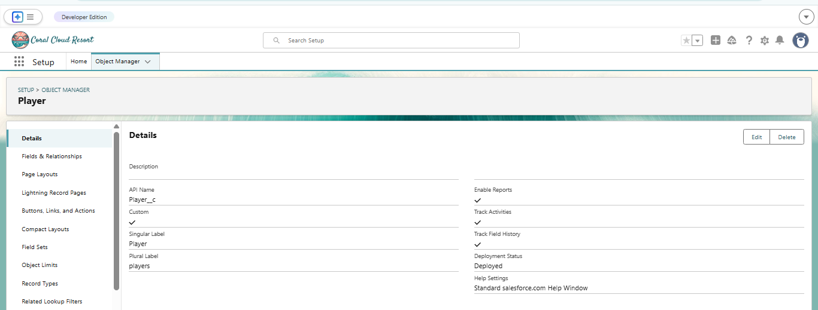
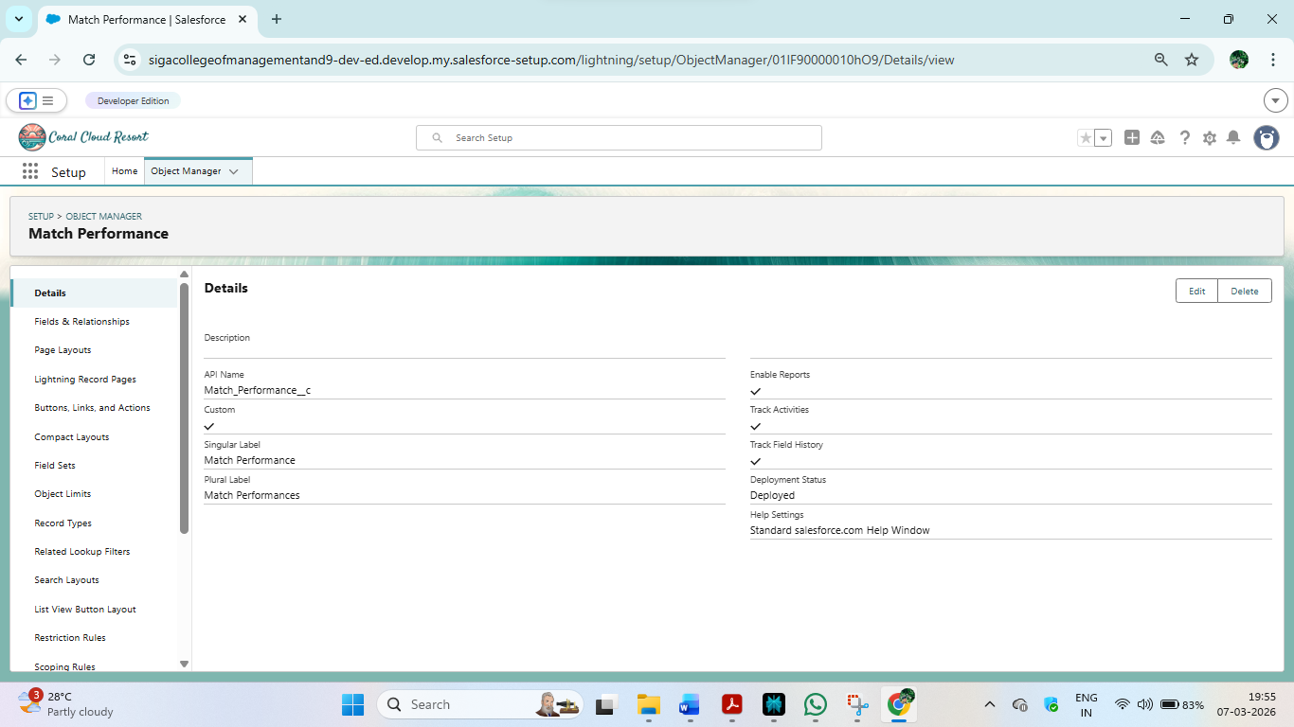

Tabs creation

2-
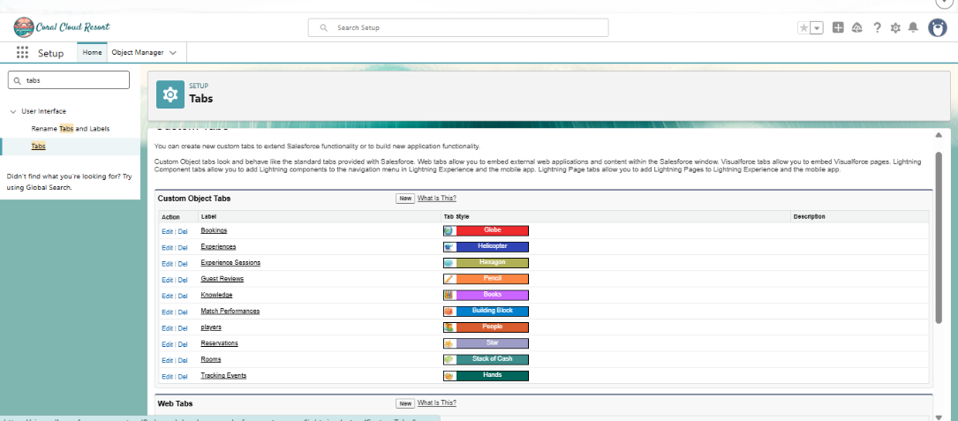

3 The Lightning App creation

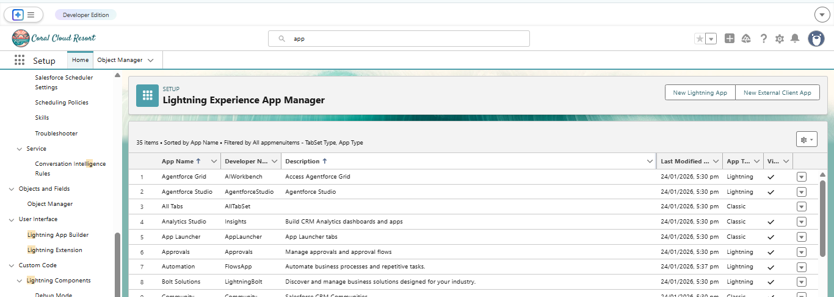

5 : Fields & Relationships

Player object

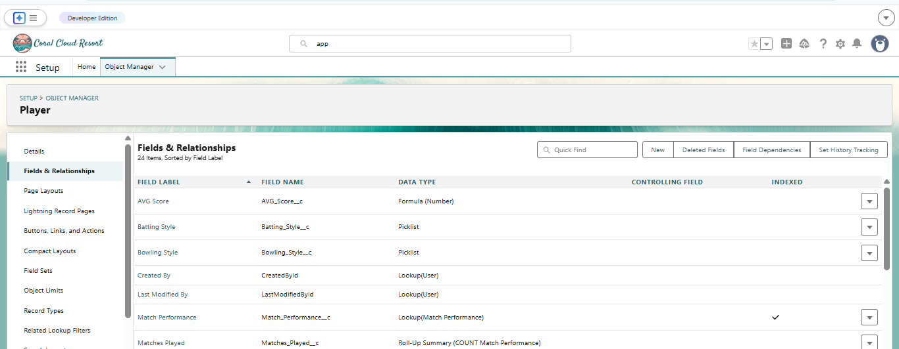

Match performance

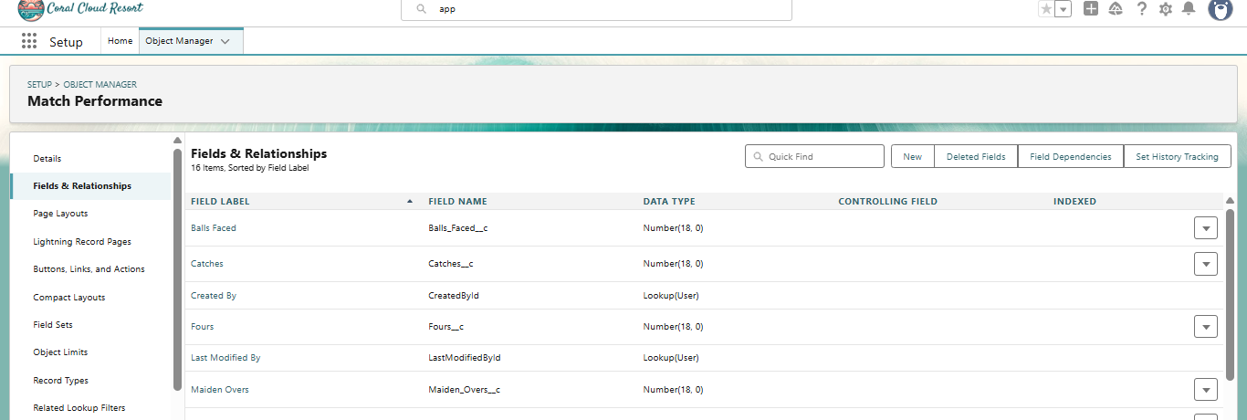

6 : Roll-up Summary

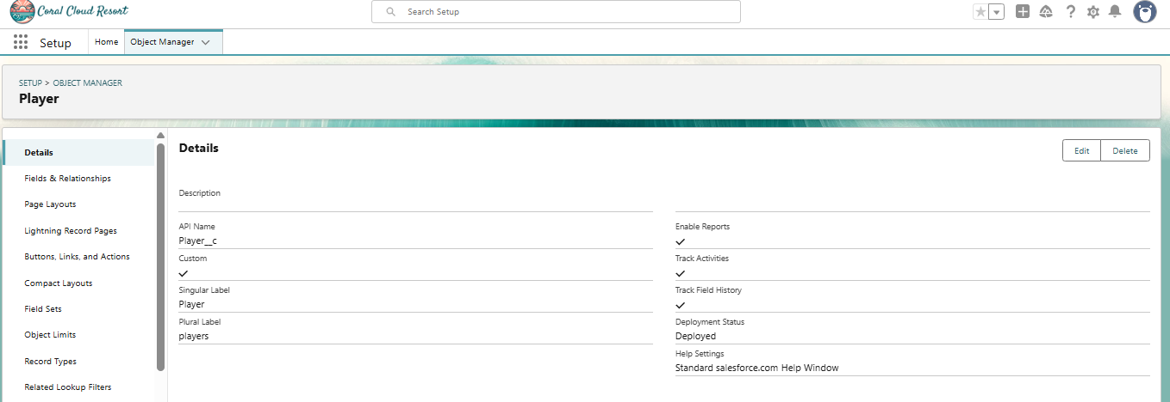

7: Flows

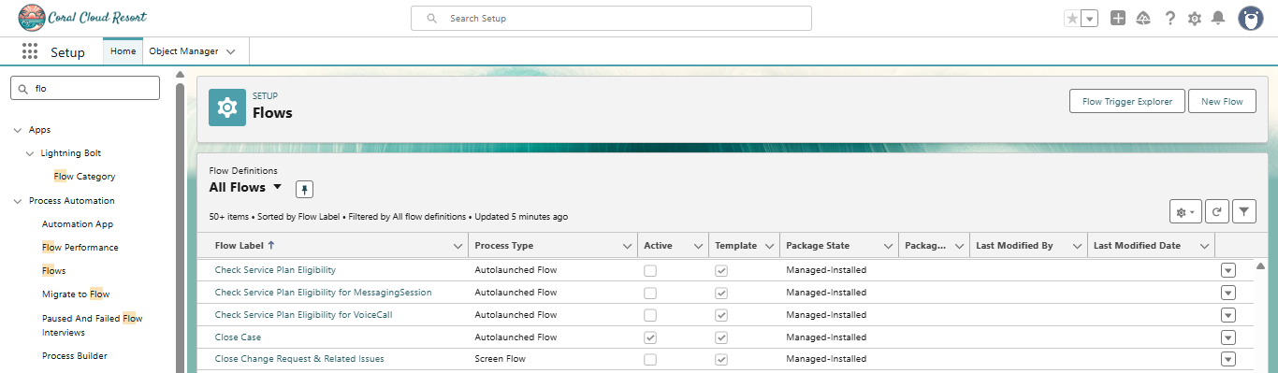

Screen flow

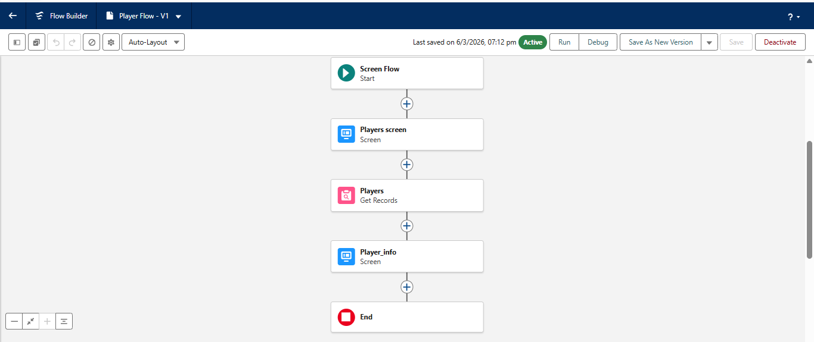

7. FUNCTIONAL & PERFORMANCE TESTING

During the testing phase, screenshots were captured from the Salesforce Lightning user interface to verify the correct functioning of all implemented features in the CRICKSTATS system. These include record creation for Player and Match Performance objects; validation rule checks for mandatory fields, score limits, and input constraints; verification of record type behavior for Domestic and International match categories; and flow execution for automatic updating of player statistics and data consistency. The functionality of roll-up summary fields was also tested to ensure accurate calculation of total runs, wickets, averages, and performance metrics.

In addition, system performance was evaluated by monitoring response time during data entry, report generation, and dashboard loading. The application was tested under multiple user interactions to ensure stable performance without delays. Screenshots of generated reports and interactive dashboards were documented to confirm accurate data visualization, real-time updates, and reliable performance tracking.

PLAYERS

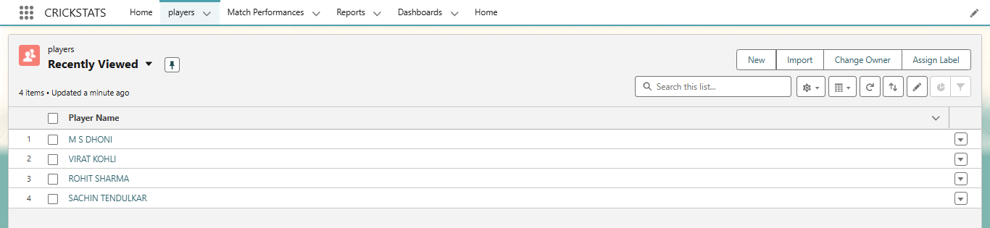

MATCH PERFORMANCES

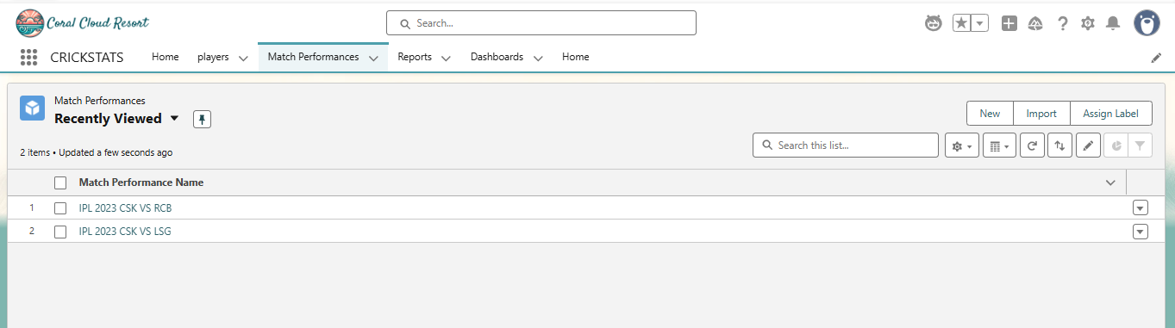

REPORTS

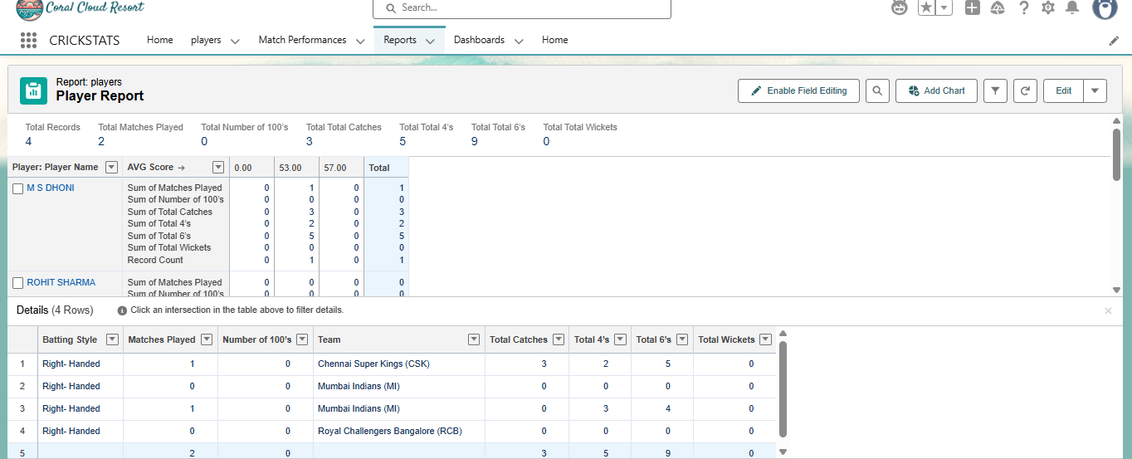

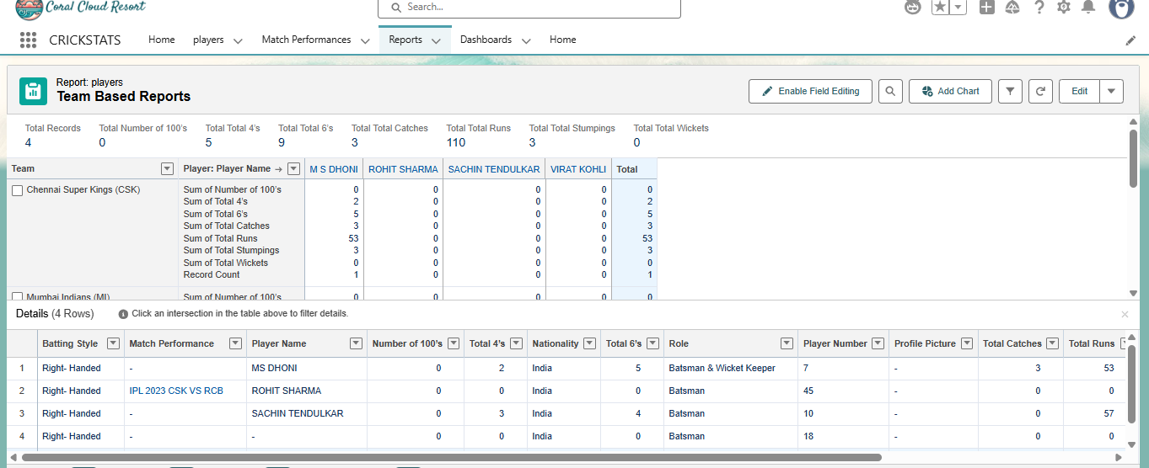

DASHBOARDS

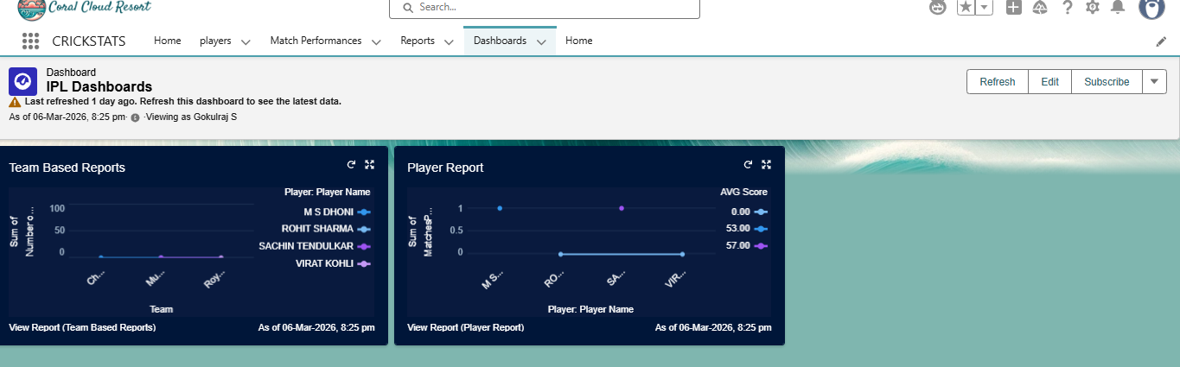

9. Conclusion:
CRICKSTATS successfully implements a cloud-based cricket performance tracking system using Salesforce. The system automates data management, improves reporting accuracy, and supports informed decision-making.
The project demonstrates practical application of SDLC, Agile methodology, and CRM-based development.

The development of CRICKSTATS represents a significant step toward modernizing cricket performance tracking and analysis. By combining traditional statistics with advanced technologies such as cloud computing, APIs, and interactive visualization, the application provides a comprehensive platform for coaches, analysts, players, and fans.
Through its structured phases—ideation, requirement analysis, design, development, and planning—the project ensures that every aspect of the system is carefully aligned with stakeholder needs. The modular architecture, role-based access, and scalable infrastructure make CRICKSTATS adaptable for both local clubs and professional leagues.

Thank
You….

